**3rd October, 2024.**

**Work Done.**

[Download, create, and install](https://redpitaya.readthedocs.io/en/latest/quickStart/SDcard/SDcard.html) the Redpitaya OS image.

Startup, network interface configuration, and communication (SSH, Serial – minicom and putty, Webpage).

A glance through the Redpitaya documentation.

**12th October 2024.**

**Work Done.**

Deep dive into the official [*Redpitaya documentation*](https://redpitaya.readthedocs.io/en/latest/)

Check[*4.2.2.6. Create your WEB applications*](https://redpitaya.readthedocs.io/en/latest/developerGuide/software/build/webapp/webApps.html) for a better understanding of the following work below.

**24th November 2024.**

**Work Done.**

LED on WEB

Error encountered: ***segmentation fault***

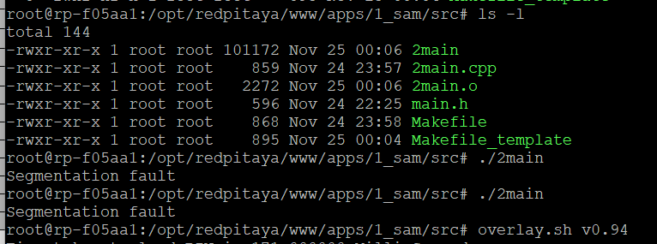

**2nd December 2024**

**Work Done.**

LED on WEB Continued, segmentation fault solved.

Things to note.

* Make sure to use the ***rw*** command before starting anything.
* Your project folder name must be the same value as ***APP.config.app_id*** in the app.js file.
* Ensure to use the appropriate ecosystem that works for your OS version.
* For compilation, just run ***make*** in your project base directory.
* Do not run ***make <name_of_cpp_file>,*** if you do, never try running the compiled file.

**4th December 2024**

**Work Done.**

Modification of Files to individually control a single LED and all LEDs.

**6th December 2024**

**Work Done.**

Modification and Running the Generator example files.

Due to constant usage of the Apps directory (/opt/redpitaya/www/apps/), a variable that holds this directory as a value was created as follows;

* Run this on the terminal (this method will only work once while the OS is running, after a reboot or shutdown, you must rerun the command): **export APP=/opt/redpitaya/www/apps**
* To avoid this, proceed to do the following: **nano /etc/environment**
* Enter this into a new line in the nano software window: **APP=/opt/redpitaya/www/apps**
* Press control X, then press y, then press enter (this is to save changes and exit nano).
* Lastly, run this command (this will update Linux to implement the new change): **source /etc/environment.**
* To confirm your variable, run: **echo $APP**

**9th December 2024**

**Work Done.**

Design of UI for LEDs. Development of frontend codes (HTML, CSS, and JS) for the designed UI (in progress) – ***ledv5_7***.

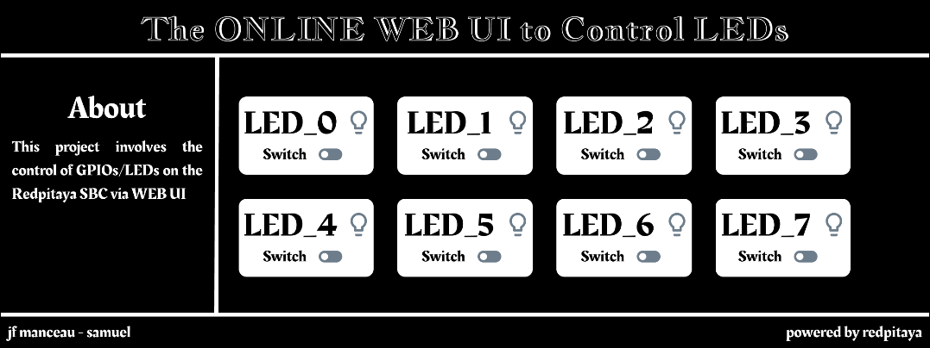

**10th December 2024**

**Work Done.**

Completion of Development of frontend codes for the designed ***Custom*** UI for ***ledv5_7***. See the Project files [here](https://github.com/JFManceau1/Projet_SOlafusi/tree/main/1_LED/led/ledv5_7).

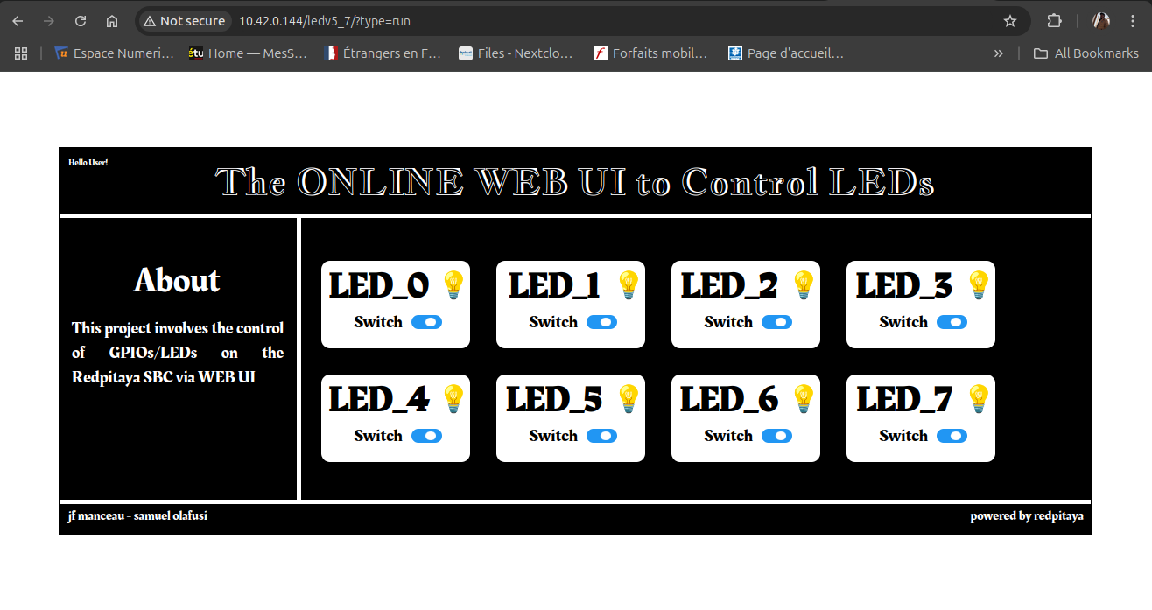

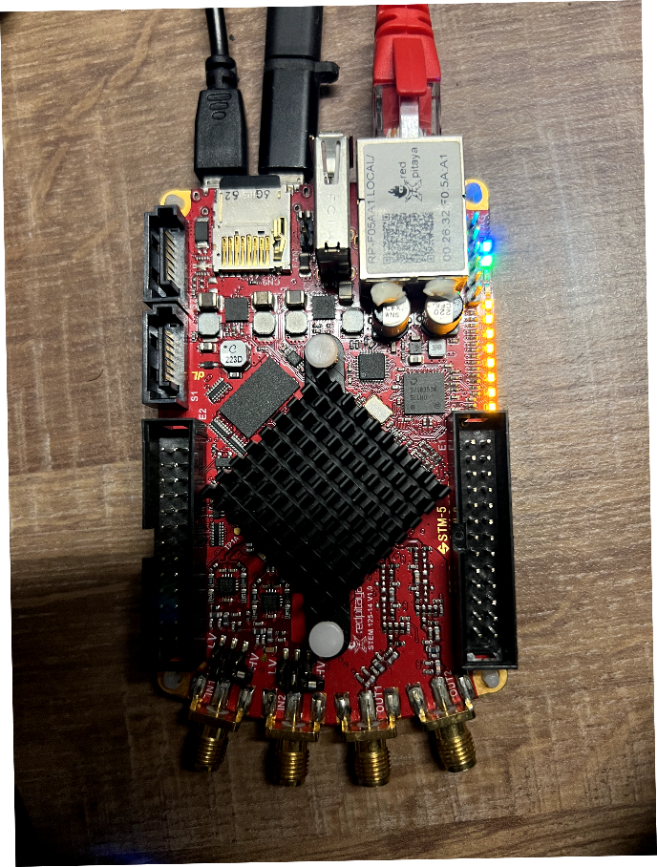

**12th December 2024**

**Work Done.**

Design of UI for Function Generator.

[See guide here](https://redpitaya.readthedocs.io/en/latest/appsFeatures/examples/generation/genRF-1-continuous.html)

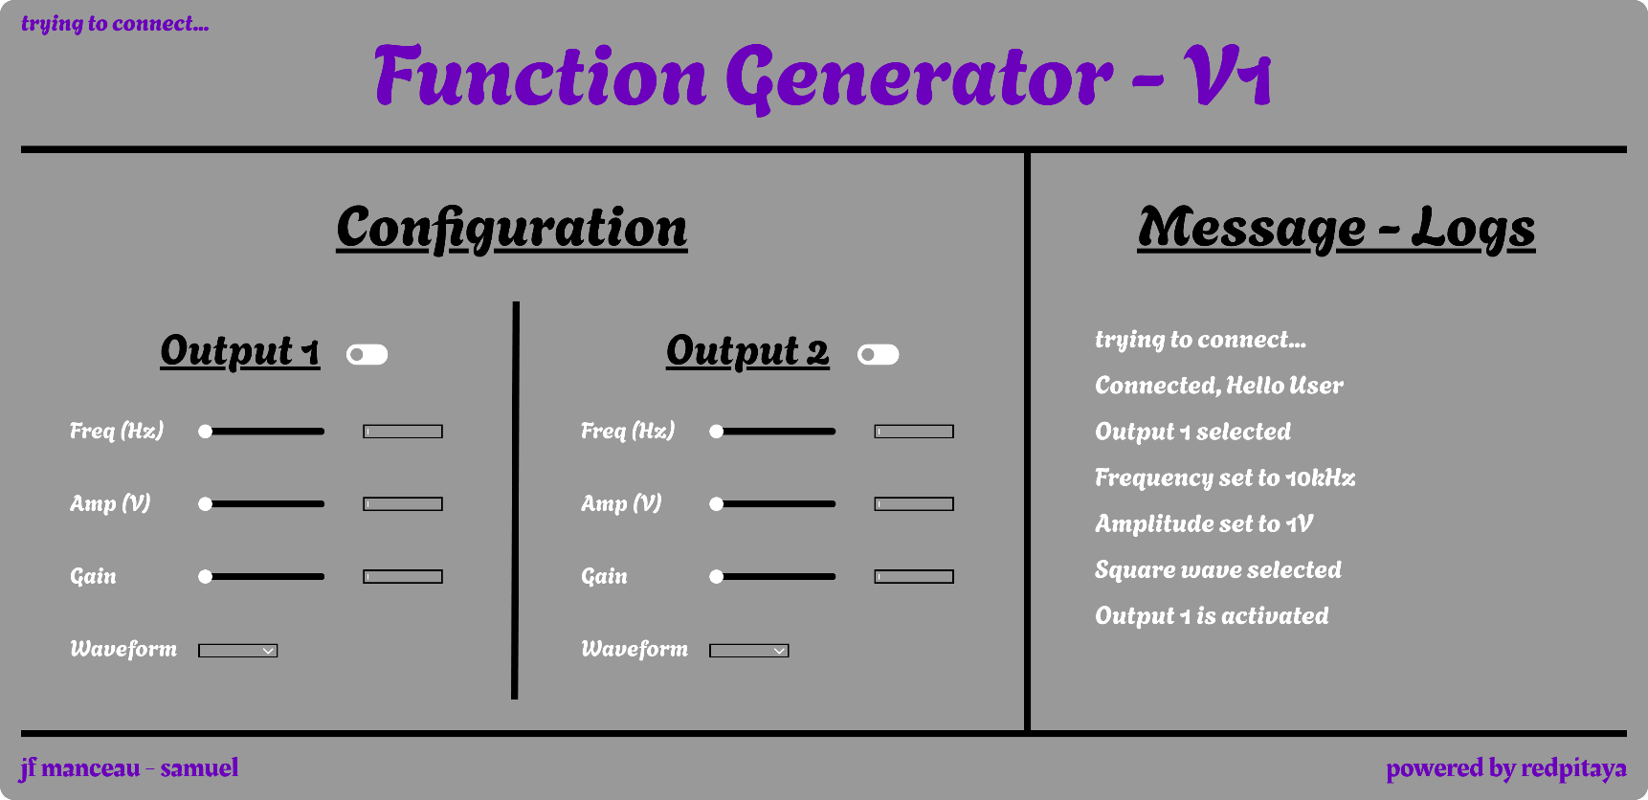

**16th December 2024**

**Work Done.**

Developing frontend codes (HTML, CSS, and JS) for the Gen UI design is in progress.

**17th December 2024**

**Work Done.**

Lab work: testing code from the ecosystem to determine the instrument’s properties and limits.

Output signal properties/limits including frequency, amplitude, gain, and output load were checked and tested.

**10th January 2025**

**Work Done.**

Developing frontend codes (HTML, CSS, and JS) for the Gen UI design is in progress – **V1.0.**

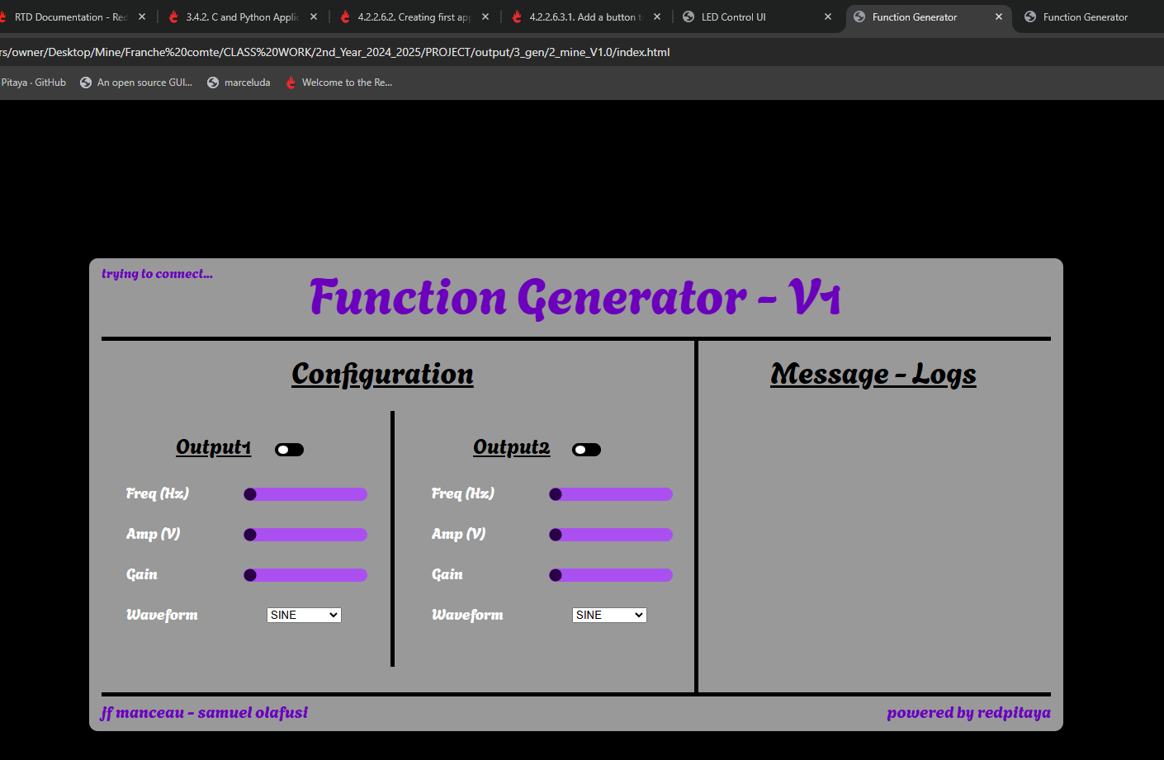

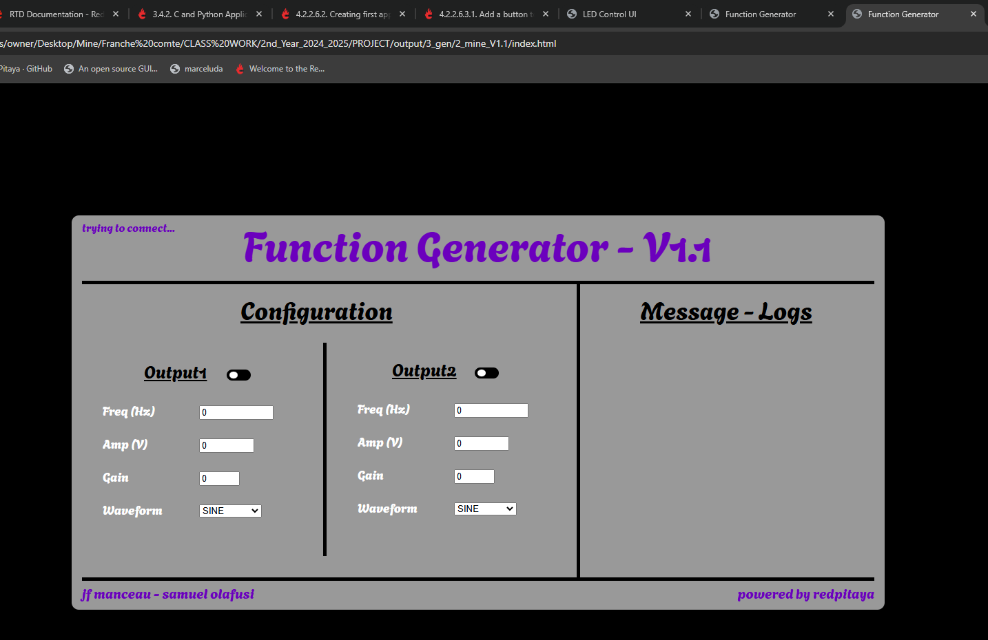

**16 & 17th January 2025**

**Work Done.**

Developing frontend codes (HTML, CSS, and JS) for the Gen UI design is in progress – V2.0 & V2.1.

**V2.0**

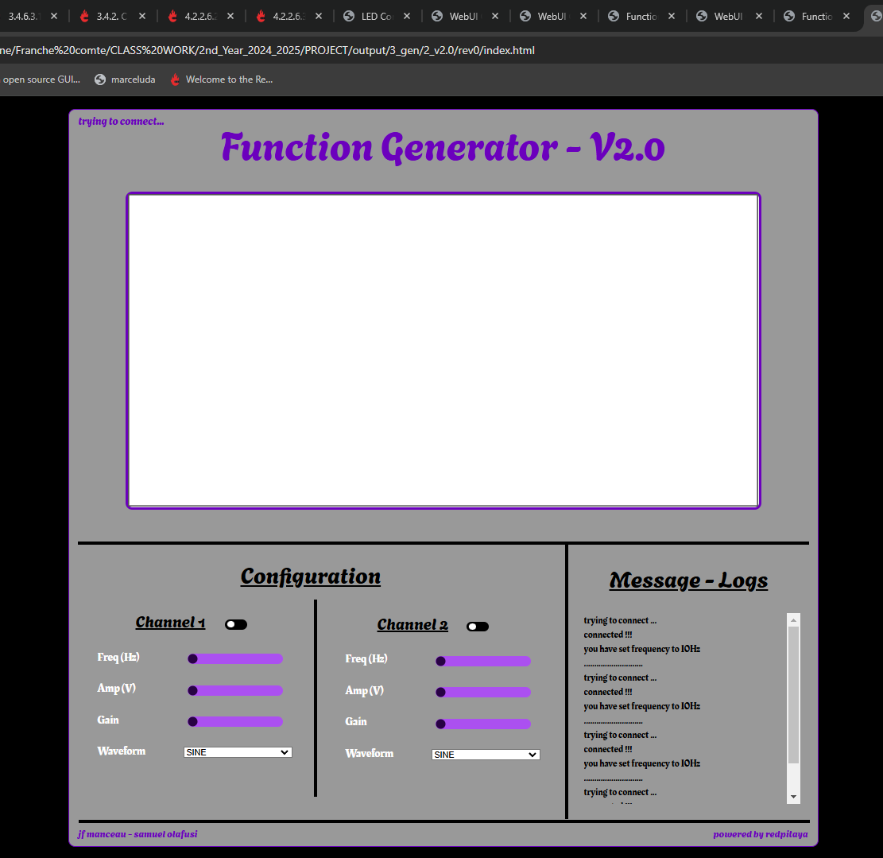

**V2.1**

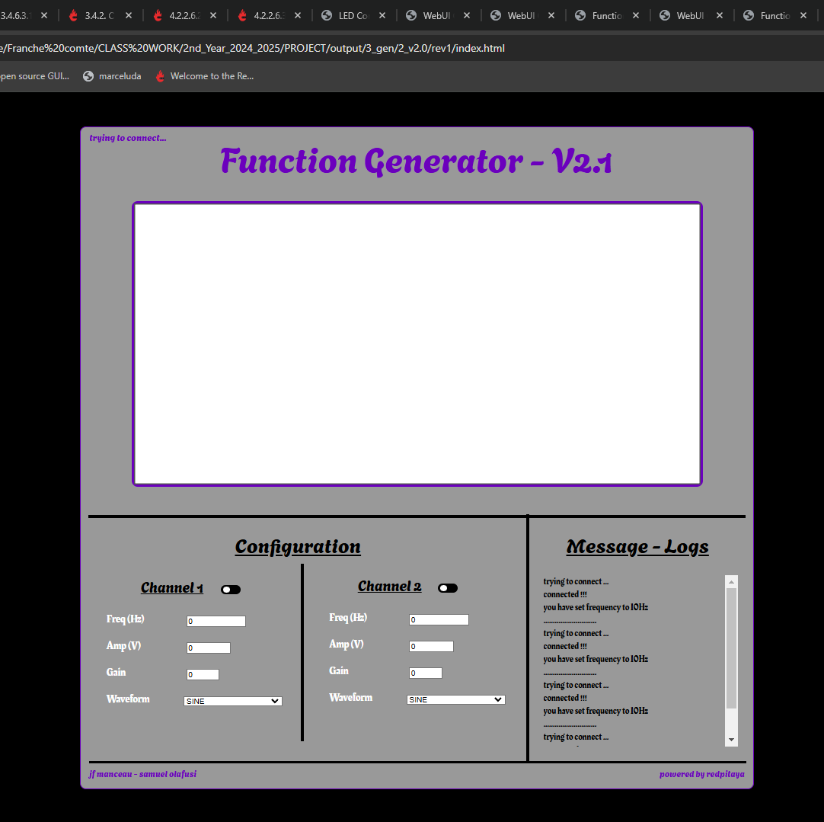

**20th Jan 2025**

**Work Done.**

Lab work, testing the work so far, by observing the signals with an oscilloscope.

Didn’t work as expected, although, there was an output at the port as seen on the oscilloscope, the user inputs didn’t change the signal properties.

Further troubleshooting will be done.

**28th to 29th Jan 2025**

**Work Done.**

Checking the codes (rev0_0, rev1_0, rev2_0) to form a revision 3.0….

**30th Jan 2025**

**Work Done.**

Lab Work, testing revisions.

* 3.0.0: only channel 1 works
* 3.0.0.1: only channel 2 works
* 3.0.1: both channels working without toggles
* 3.0.2/3: both channels working with toggles

**31st Jan 2025**

**Work Done.**

Lab Work, Project demonstration.

* LED demonstration.
* Signal Generator demonstration.
* Project Discussion and further work.

**Moving Forward, the following will be done.**

* Make documentation reports robust and comprehensive showing technical methodologies.
* Create a numeric input type and add a phase for the generator.
* Develop Oscilloscope and acquisition of signals.

**5th to 6th Feb 2025**

**Work Done.**

Creation of a numeric input type, phase, and offset for the function generator – V3.0.4.

Added comments on the Generator and LED codes.

